Grazioso Salvare Rescue Dog Dashboard (MongoDB + Dash Application)

About the Project/Project Title
This project implements a full-stack Python-based interactive dashboard application that connects a MongoDB backend database with a client-facing web interface built using Dash.
The system is designed for Grazioso Salvare, an organization that identifies and trains search-and-rescue dogs. The dashboard allows users to filter and visualize animal shelter data from the Austin Animal Center dataset to identify dogs suitable for different types of rescue training including water rescue, mountain/wilderness rescue, and disaster/individual tracking.
The application integrates:
- A MongoDB database as the backend data model
- A Python CRUD module for database operations
- A Dash web application for interactive visualization
- Geolocation mapping and statistical charting for decision support

Motivation
The motivation behind this project is to demonstrate how full-stack data-driven applications are built using modern database and visualization tools.
In real-world systems, organizations rely on interactive dashboards to make data-driven decisions. Grazioso Salvare requires a system that can efficiently filter large animal shelter datasets to identify suitable search-and-rescue dogs.
This project demonstrates:
- How MongoDB can be used as a flexible NoSQL data model
- How Python can act as a middleware layer for database access
- How Dash can be used to build interactive analytical dashboards
- How data visualization improves decision-making efficiency
The system is designed to reduce manual filtering effort and improve accuracy in selecting rescue candidates.

Getting Started
To get a local copy up and running, follow these steps:
- Open a Codio environment
- Navigate to the datasets directory
  - cd ./datasets
- Import the dataset into MongoDB
  - mongoimport --type=csv --headerline --db aac --collection animals --drop ./aac_shelter_outcomes.csv
- Open the MongoDB shell
  - mongosh
- Create the database user
  - use admin
db.createUser({
user: "aacuser",
pwd: "SNHU1234",
roles: [{ role: "readWrite", db: "aac" }]
})
- Open Jupyter Lab in Codio
- Navigate to the project code files directory
- Run ProjectTwoDashboard.ipynb to launch the dashboard application

Installation
MongoDB
- Used as the backend database system
- Stores structured animal shelter records
- Provides fast querying and flexible document storage
PyMongo
- Python driver used to connect to MongoDB
- Enables CRUD operations from Python code
Python 3
- Core programming language used for:
  - Database interaction
  - Data filtering logic
  - Dashboard callback functions
Dash (Plotly Dash)
- Framework used to build interactive web dashboards
- Provides reactive UI components and callbacks
Dash Leaflet
- Used for geolocation visualization on interactive maps
Plotly Express
- Used for dynamic data visualization (pie charts)
JupyterDash
- Allows running Dash applications inside Jupyter Notebook environments

Usage
This dashboard allows users to interact with animal shelter data using filter-based controls.
Functionality includes:
• Filter by Rescue Type
- Water Rescue
- Mountain / Wilderness Rescue
- Disaster / Individual Tracking
- Reset (returns full dataset)
• Interactive Data Table
- Displays MongoDB records
- Updates dynamically based on filters
- Supports sorting, pagination, and row selection
• Geolocation Map
- Displays animal location using latitude and longitude
- Shows breed and name of selected animal
• Pie Chart Visualization
- Displays breed distribution
- Updates dynamically based on filter selection

Code Example
Below is an example of how the CRUD module is used to retrieve data for the dashboard:

from CRUD_Python_Module import AnimalShelter
import pandas as pd

# Establish connection to MongoDB using application credentials
db = AnimalShelter("aacuser", "SNHU1234")

# Retrieve records from the animals collection
# An empty query returns the full dataset
data = db.read({})

# Convert MongoDB results into a Pandas DataFrame
df = pd.DataFrame.from_records(data)

# Remove MongoDB internal identifier field for compatibility with Dash components
df.drop(columns=['_id'], inplace=True)

This example demonstrates how the CRUD module abstracts database operations from the dashboard layer, allowing the application to separate data access logic (MongoDB interactions) from presentation logic (Dash interface and visualizations).

Tests
Testing was performed using Jupyter Notebook execution and manual dashboard interaction.
Steps performed:
- Imported the CRUD Python module
- Connected to MongoDB using the AnimalShelter class
- Verified data retrieval using read() method
- Tested each filter option:
  - Water Rescue
  - Mountain Rescue
  - Disaster Rescue
  - Reset
- Verified data table updates dynamically
- Verified pie chart updates correctly
- Verified geolocation map updates based on selected row
- Confirmed all CRUD operations returned expected results
All tests confirmed correct system behavior and dynamic responsiveness.

Screenshots
Dashboard Initial State
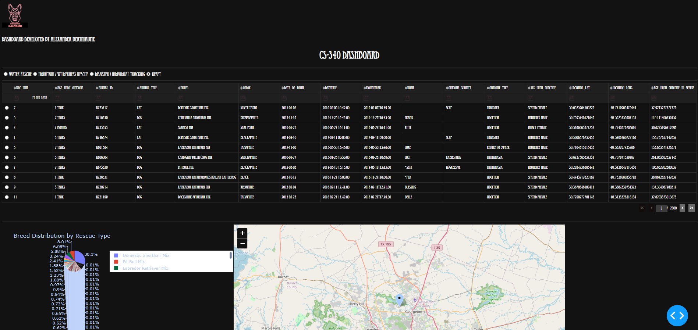 Water Rescue Filter Applied
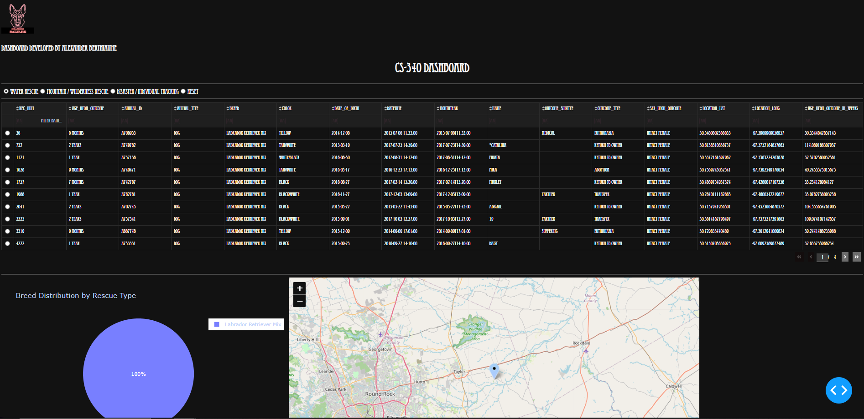 Mountain / Wilderness Rescue Filter Applied
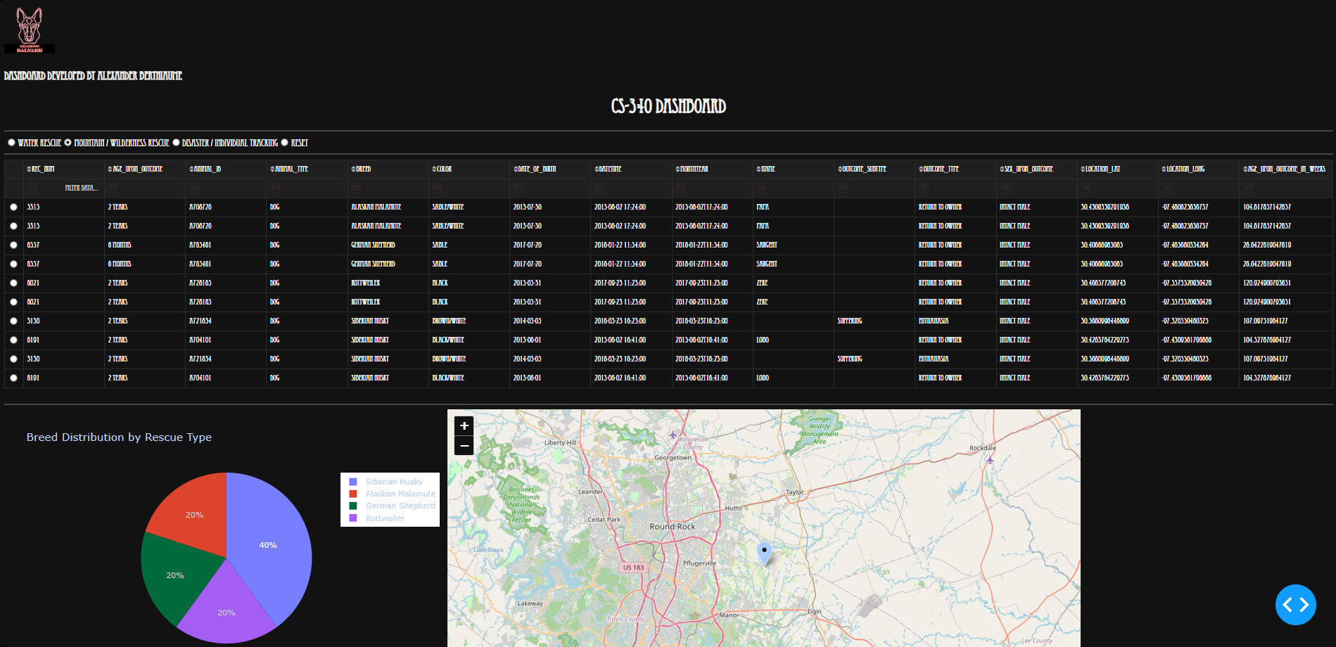 Disaster / Individual Tracking Filter Applied
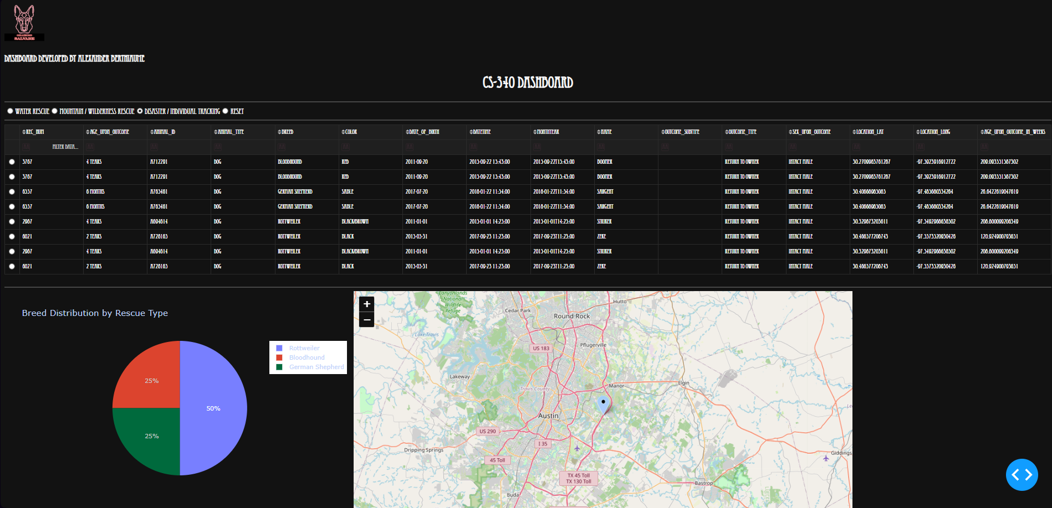 Reset View
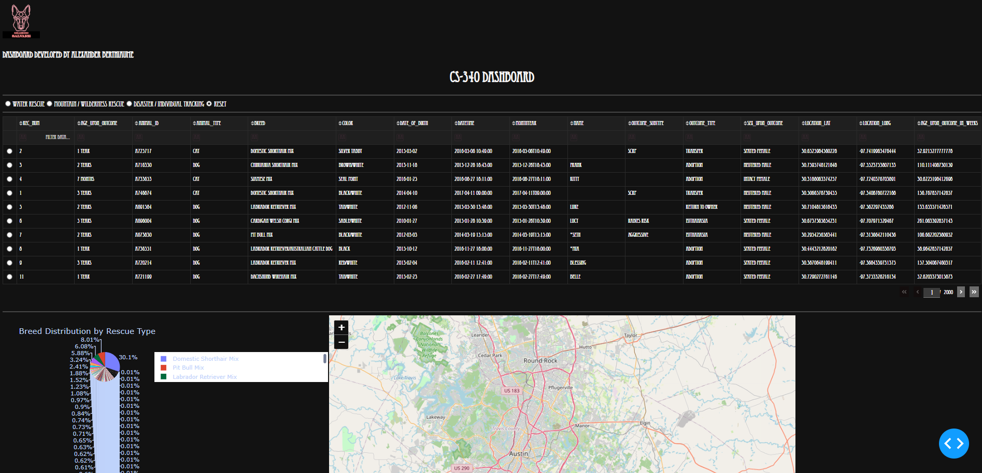

Challenges and Solutions
Challenge 1: MongoDB Query Filtering
Some initial queries did not properly filter based on breed and age.
Solution:
Refined query structure using $in, $gte, and $lte operators.

Challenge 2: Dash Callback Errors
Callbacks initially failed due to NoneType inputs.
Solution:
Added input validation checks before iterating over data.

Challenge 3: Map Indexing Issues
Map markers failed when dataset structure changed.
Solution:
Replaced index-based referencing with column-based access.

Challenge 4: Interactive Synchronization
Widgets were not updating together consistently.
Solution:
Linked all components through shared Dash callbacks using derived_virtual_data.

Contact
Name: Alexander Berthiaume
Project: CS 340 Project Two - Grazioso Salvare Dashboard
Institution: Southern New Hampshire University

